MCA II SEMESTER

NAME = MADHURI SHRIMALI

ROLL NO = 17

**Virtual Private Cloud**

In Google Cloud Platform (GCP),A Virtual Private Cloud (VPC) in GCP is a secure, isolated virtual network that lets you build and manage your own private cloud environment. It acts as a foundational networking service, enabling you to control how your cloud resources (like virtual machines, databases, and containers) communicate with each other, with other GCP resources, or with external networks. Unlike traditional on-premises networks, VPCs are software-defined and fully customizable, providing a high level of flexibility, security, and scalability.

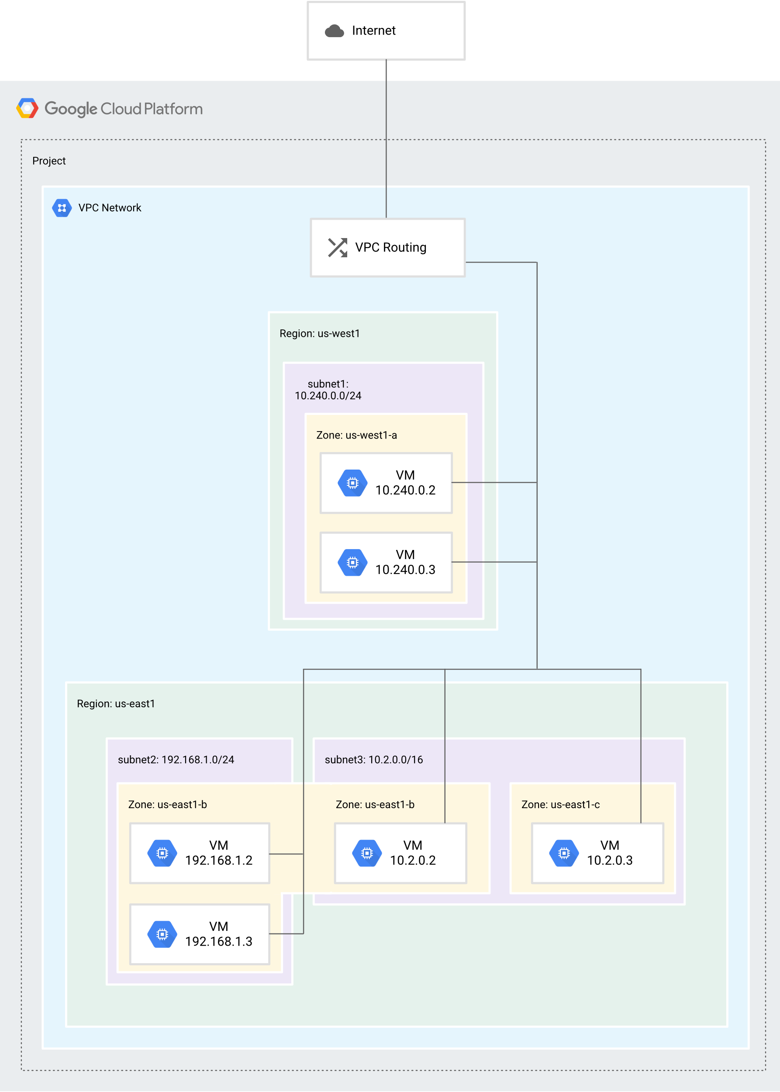

**Key Features of VPC in GCP**

VPC offers several core features that make it a powerful tool for cloud networking:

1. **Private Network Isolation**: VPC creates a logically isolated network environment, ensuring that your resources are separated from other GCP users or projects. This is achieved through software-based segmentation, which prevents unauthorized access and enhances security. For example, traffic within your VPC stays private and doesn't traverse the public internet unless explicitly configured.
2. **Customizable IP Addressing**: You can define your own IP address ranges (e.g., using CIDR blocks like 10.0.0.0/16) for the VPC. This allows you to align your cloud network with your organization's existing IP schemes, avoiding conflicts and making it easier to migrate from on-premises setups.
3. **Subnets**: Subnets are subdivisions of your VPC that organize resources into smaller, regional segments. Each subnet is tied to a specific GCP region (e.g., us-central1) and has its own IP range. This helps in distributing resources geographically for better performance, compliance, and management. For instance, you might place web servers in one subnet and databases in another for enhanced security through separation of concerns.
4. **Firewall Rules**: These are stateful rules that control traffic flow to and from resources in your VPC. You can specify criteria like source/destination IP addresses, ports, protocols (e.g., TCP/UDP), and even tags on resources. Firewall rules apply globally across the VPC but can be tailored per subnet or instance, providing granular security. GCP's firewall is integrated with Identity and Access Management (IAM), allowing you to enforce policies based on user roles.
5. **Routing**: Routing in VPC determines how network traffic is directed. You can create custom route tables with static routes (manually defined) or dynamic routes (using protocols like BGP for peering). This includes routing between subnets, to the internet, or to external networks. For example, you can set up routes to direct internal traffic within the VPC while routing external traffic through a VPN for added security.
6. **Peering and Connectivity Options**:
   * **VPC Peering**: This allows you to connect two VPC networks (even across different projects or organizations) without using public IP addresses. Traffic between peered VPCs remains private and secure, ideal for multi-team collaborations.
   * **VPN and Interconnect**: Use Cloud VPN for encrypted connections to on-premises networks over the internet. For high-performance needs, Dedicated Interconnect or Partner Interconnect provides direct, low-latency links to your VPC, bypassing the public internet for better reliability and speed.
7. **Shared VPC**: This feature enables multiple GCP projects within an organization to share a single VPC network. It's managed centrally (e.g., by a network admin), while individual projects can deploy resources into it. This promotes resource efficiency and simplifies governance in large enterprises.
8. **Private Google Access**: Instances in your VPC can access GCP services (like Google APIs, BigQuery, or Cloud Storage) without needing public IP addresses. Traffic is routed through Google's internal network, enhancing security and reducing exposure to the public internet.
9. **Service Control Policies**: These policies let you monitor and restrict access to GCP services from your VPC. For example, you can enforce quotas, block certain APIs, or log access attempts, integrating with GCP's broader security tools like Cloud Armor.

**Components of a VPC**

VPC is built from several interconnected components:

1. **VPC Network**: This is the top-level entity that defines the entire private network. It spans multiple regions and includes the primary IP address space. You can create multiple VPCs per project for different environments (e.g., one for development and one for production).
2. **Subnets**: As mentioned, these are regional segments of the VPC. Each subnet inherits the VPC's IP range but can have a subset (e.g., a VPC with 10.0.0.0/16 might have a subnet with 10.0.1.0/24). Resources in a subnet can communicate with each other by default, but you control external access via firewall rules.
3. **Firewall Rules**: These are essentially access control lists (ACLs) that filter traffic. They can be applied at the VPC level or to specific resources, supporting both allow and deny rules.
4. **Routes**: These define the path for traffic. GCP provides default routes (e.g., for internet access), but you can customize them. Routes can point to gateways, peered VPCs, or VPN tunnels.
5. **External IP Addresses**: These are public IPs assigned to resources (e.g., a VM) to enable outbound internet access or inbound connections. They can be ephemeral (temporary) or static.
6. **Internal IP Addresses**: These are private IPs used for communication within the VPC. They ensure that internal traffic remains isolated and secure.

**How VPC Works**

Here's a step-by-step overview of setting up and using a VPC:

1. **Creating a VPC**: In the GCP Console, you create a VPC by specifying a name and an IP address range (e.g., 10.0.0.0/16). You can also configure initial settings like default routes or firewall rules during setup.
2. **Defining Subnets**: After creating the VPC, add subnets for specific regions. Assign an IP range to each subnet and associate it with the VPC. This step organizes your network topology based on workload needs.
3. **Setting Up Firewall Rules**: Configure rules to secure your resources. For example, allow HTTP traffic (port 80) from specific IP ranges while denying all other inbound traffic. Rules are applied automatically to resources in the VPC.
4. **Configuring Routes**: Define how traffic flows. For instance, set up a route to send traffic from a subnet to the internet via a Cloud NAT gateway, or create routes for VPC peering.
5. **Connecting to Other Networks**: Establish connections using VPC Peering for internal GCP networks or Cloud VPN/Interconnect for on-premises integration. This ensures seamless data exchange without compromising security.
6. **Deploying Resources**: Once configured, deploy resources like Compute Engine VMs or Kubernetes clusters into the VPC. They use internal IPs for intra-VPC communication and can be accessed externally if firewall rules permit.

In summary, VPC in GCP provides a robust framework for building secure, scalable networks. It's integrated with other GCP services, making it easy to scale as your needs grow.

**Advantages:**

* **Enhanced Security and Isolation**: Provides private, segmented networks that protect resources from external threats, with features like firewall rules and private access to Google services.
* **Flexibility and Customization**: Allows custom IP schemes, subnets, and routing, making it adaptable for complex architectures and hybrid cloud setups.
* **Scalability and Cost-Efficiency**: Easily scales with your workload without hardware limits, and you only pay for what you use (e.g., data transfer costs are minimized with internal routing).
* **Integration**: Seamlessly connects with GCP tools (e.g., for AI/ML or data analytics) and external networks via peering or VPN, reducing management overhead.
* **Centralized Management**: Features like Shared VPC enable organization-wide control, ideal for enterprises.

**Disadvantages:**

* **Complexity**: Setting up and managing VPCs (e.g., routes, firewalls, and peering) requires expertise, leading to a steep learning curve for beginners.
* **Cost Implications**: While scalable, inter-region data transfer or VPN usage can incur unexpected costs; also, misconfigurations might lead to inefficient resource use.
* **Dependency on GCP**: It's tied to the GCP ecosystem, so migrating to another cloud provider can be challenging due to proprietary features.
* **Performance Limitations**: In high-latency scenarios (e.g., global subnets), traffic routing might introduce delays if not optimized.
* **Potential Security Risks**: If firewall rules or routes are poorly configured, it could expose resources, requiring ongoing monitoring.